ÀREA: CLÀSSIQUES
TOPIC: A ROMAN TOWN

The Romans conquered Italy, Gaul, the Balkan Peninsula, Iberia, Portugal, Turkey, the Middle East and the north of Africa all around the Mediterranean Sea. However, we usually forget that they also went as far west as Britain, conquering most of the island except for some parts of Wales and the north of Scotland. This means that they also settled there building their roads, camps and towns. Read this text and you will learn about Roman towns in Britain. Then do the following activities.

The texts for this activity comes from the very recommendable website The Romans in Britain. Don’t forget to pay it a visit. You won’t regret it. Here is their address:

http://www.romans-in-britain.org.uk/arc_roman_towns.htm

THE STRUCTURE OF ROMAN TOWNS
When the Romans arrived in Britain in 43AD, they took over a country that was disorganised, fragmented, and divided into sections, each occupied by a different race of people. There was no central administrative centre, no road network, no law or order. There wasn't even a single currency in use throughout the land. It was clear that there had to be a massive rebuilding programme from the roots up. Not just in building terms, but also in educating the natives to accept a new way of life.
As the Romans moved further inland, they built effective roads, grand and impressive buildings and established strategic centres, both civil and military in the form of the Roman town. Within 17 years of the invasion, they had several major towns in place. connected by the famous Roman roads. The three largest we now know as London, Colchester and St. Albans. Even though towns where built across the country, they all had several factors in common both physical and structural.
There was one thing that is noticeable in many towns. The Romans were no respecters of the homes of the natives. Towns such as Canterbury, Chichester, Silchester and St. Albans were found by archaeologists to have been built over the foundations of Celtic settlements. Whether the occupants went voluntarily and had alternative homes is unclear. Either way, the Romans demolished their homes and built their own constructions in place of the native dwellings.
Questions:
When Britain was invaded by the Romans in 43AD, what sort of society did they find? What was the difference between both worlds?

The Romans started building their roads and towns. Generally they were strictly planned before they were built, but in some cases (like Chichester, Dorchester, etc.) this did not really happen. Why?

THE LAYOUT OF A ROMAN TOWN
Anything the Romans built had a structure and order about it, along with a specific purpose and reason behind the method. Although there are some variations, this is the general layout of a Roman town.
The town would have two main roads. One heading North-South and the other East-West. The directions were not always spot on, they may have been several degrees either way. But the general direction was constant. At the point where these roads met was the town centre and it was here that the administrative centre, the forum and the market could be found. From here the town would radiate outwards with new roads being built as needed. The roads would be at right angles to each other and parallel with one of the two main roads. In the central portion of the town would be the main businesses, with the homes and dwellings of the citizens further towards the edges of the town.
Even in Roman times, traffic congestion was a major problem with merchants arriving with goods for the shops, travellers passing through, service workers moving to their next appointment and pedestrians going about their business. In the larger towns this congestion was so bad that the council had to place traffic controllers at main junctions. This was normally a Roman soldier who had been seconded to civil duties.
Depending on their use and importance to the community, the roads were between 16 to 26ft (5m to 8m) wide and constructed with a surface of gravel which was cambered to allow for rainwater drainage. Due to the heavy use, the roads needed to be repaired regularly and they were completely relaid every 25 years. The constant resurfacing work meant that the road surface increased in height over the years, and many roadside shops eventually had entrances below road level.

Questions
Describe the general layout of a Roman town.

What do you learn about the traffic in a Roman town?

What buildings could we usually find at the heart of the town? What was their use?

How wide were the roads in a town? What were they made with? What happened to them after heavy use? Any consequences for other buildings?

Look at the following map of Camulodunum, present Colchester, a Roman town in Britain. Put what you have learnt from the text into practice and describe what you see in the map.
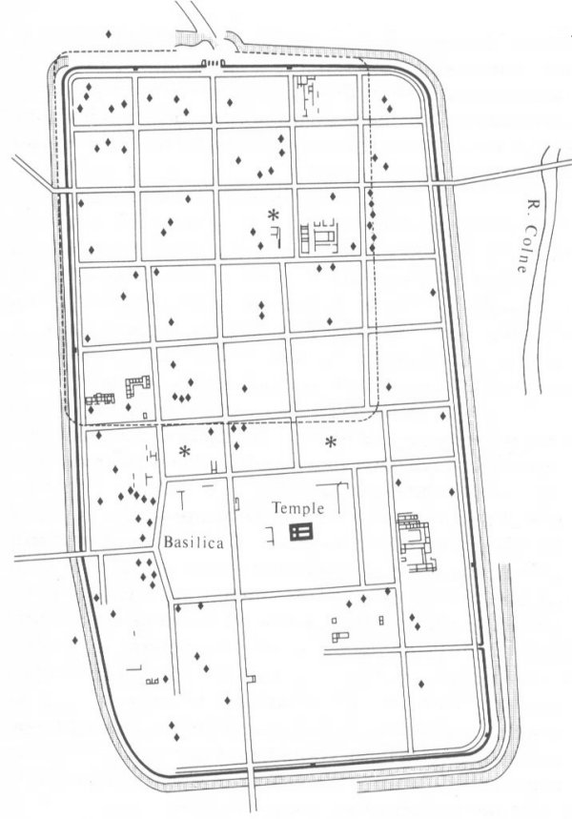

………………………………………………………………………………………………………………………………………………………………………………………………………………………………………………………………………………………………………………………………………………………………………………………………………………………………………………………………………………………………………………………………………………………………………………………………………………………………………………………………

Text and map from http://www.romans-in-britain.org.uk/arc_roman_towns.htm

